**Heifetz-Tussman, Malka (1893-1987)**

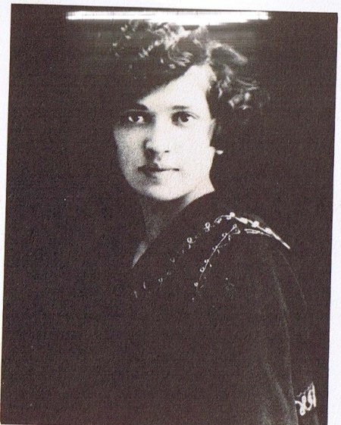

Malka Heifetz-Tussman is a twentieth-century American Yiddish poet. She was born in 1896 in the region of Volyn in Ukraine (then part of the Russian Empire), and immigrated to the United States with her family in 1912. Unlike Celia Dropkin (1887-1956) or Anna Margolin (1887-1952), Heifetz-Tussman was not based in New York, the major center of Yiddish literary creation in America, but lived in Chicago and Milwaukee, taught Yiddish language and literature at the University of Judaism in Los Angeles, then lived in Berkeley, California until her death in 1987. She received the Itsik Manger Prize for Yiddish Literature in 1981. Inspired by Walt Whitman, her poems strike a balance between a concise, dense writing style, and a quest for simplicity and accessibility. Her work focuses on the sensory experiences of the lyrical I as it encounters the natural world, reaching an intensity often expressed in mystical terms. Although never directly engaging with the experience of the Shoah, she thought of her poetry as an act of resistance, an uncompromising affirmation of her right to exist.

Thunder my brother,

My mighty brother,

Stones rolling on stones – your voice.

The force and the forest of your voice.

What a joy for you to rattle the mountains

What a bliss

To rouse the creeping creatures in the valley.

(Excerpt of *Duner mayn bruder,* published in *Lider*, 1949)

**Further Reading:**

Falk, Marcia (ed.) (1992): *With Teeth in the Earth: Selected Poems of Malka Heifetz Tussman*, Detroit: Wayne State University Press. An anthology of poems by Heifetz-Tussman in English translation very personal introduction by Marcia Falk offering us a detailed account of her encounter with Heifetz-Tussman, and insider knowledge about her personal life and poetic career.

Harshav, Benjamin and Barbara (ed.) (1986) ‘Malka Heifetz-Tussman’, *American Yiddish Poetry: A Bilingual Anthology*, Berkeley, Los Angeles, and London: University of California Press. A comprehensive bilingual anthology of most of Heifetz-Tussman’s major poems, ordered chronologically.

Hellerstein, Kathryn (1992) ‘From “Ikh” to “Zikh”: A Journey From “I” to “Self” in Yiddish Poems by Women’, in *Gender and Text in Modern Hebrew and Yiddish Literature*, New York and Jerusalem: The Jewish Theological Seminary of America. In this article, Hellerstein analyses the specificity of the lyrical I of female Yiddish poets Anna Margolin and Malka Heifetz-Tussman.

Hellerstein, Kathryn (1997) ‘Tussman, Malka Heifetz’, *Jewish Women in America: an Historical Encyclopedia*. New York: Routledge. A comprehensive summary of Heifetz-Tussman’s life and work, with bibliographical references.

**List of major works:**

Heifetz-Tussman, Malka (1949) *Lider* (Poems). Los Angeles: [s.n.].

Heifetz-Tussman, Malka (1958) *Mild mayn vild* (Mild My Wild). Los Angeles: [s.n.].

Heifetz-Tussman, Malka (1972) *Bleter faln nit*. Tel-Aviv: Yisroel-bukh.

Heifetz-Tussman, Malka (1974) *Unter dayn tseykhn* (Under Your Sign). Tel-Aviv: Yisroel-bukh.

Heifetz-Tussman, Malka (1977) *Hayntz iz eybik* (Today is Forever). Tel-Aviv: Yisroel-bukh.

**Raphael Koenig, Harvard University**

URL of Illustration:

<http://lilith.org/blog/2012/05/candles-of-song-malka-heifetz-tussman/>

copyright holder: YIVO Archive, New York